Name:__________________________________

Marks: /20

**PHYSICS STAGE HEAT WRITTEN PRACTICAL TEST**  **2023**

Specific Heat of Nickel

1. Bill and Susan set up their equipment to heat their nickel pellets as below. Susan suggests that there are several things wrong with this initial set up. List two major errors in the table below which may give invalid readings. Include explanations as to **why** you think that the errors or perceived errors will produce unreliable data.

(4 marks)

.

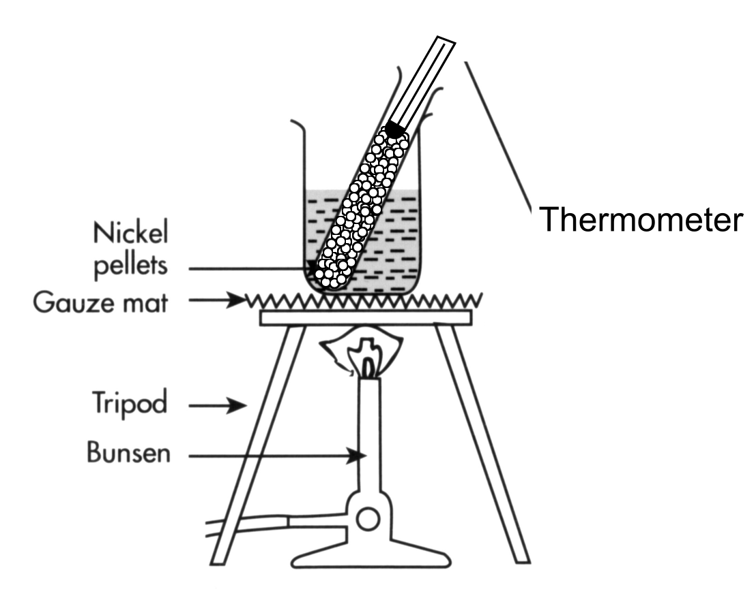

|  |  |
| --- | --- |
| Perceived Error | Explanation |
|  |  |
|  | . |

1. During the experiment, Bill followed the instructions and heated the nickel pellets to 90.0 o C. The pellets remained dry. Bill then removed the test tube containing the nickel pellets from the water bath and quickly but carefully poured the pellets into the receiving water in the styrofoam cup. He then measured the temperature of the receiving water. What is the major flaw in Bill’s procedure? Why is this a problem? (2 marks)
2. Explain why the nickel pellets have to be dry before they are transferred to the styrofoam cup? (2 marks)
3. Alex and Rory transfer their new found knowledge to calculate the specific heat of a recently discovered metal called Taylorium. Use the students’ data as listed below to determine the specific heat capacity of Taylorium. Assume that no energy is transferred to the calorimeter or the environment. Show neat and full working. (4 marks)

Data provided

* mass of Taylorium sample, mT = 57.26 g
* mass of receiving water, mw = 45.0 g
* initial temp of Taylorium, Ti = 93.0 o C
* initial temp of receiving water, Tw = 19.0 o C
* final temp of receiving water and Taylorium, Tf = 23.0 o C

Latent Heat of Fusion of Ice

1. If you used an aluminium calorimeter of the same mass instead of the copper calorimeter used in your experiment, would you need; **more, the same or less** ice (**circle your response**) to attain the same final temperature for water that was achieved with the copper calorimeter? With reference to the equation for ∆Qgained, explain the response you circled above. Note that the specific heat capacity of copper is 390 J kg-1 K-1 and the specific heat capacity of aluminium is 890 J kg-1 K-1. (3 marks)
2. Michelle and Shirley repeat the Latent Heat of Fusion experiment taking into account a

better appreciation of what is actually going on. They note that the ice was initially at 0 o C. Further, they noticed that the ice that they weighed actually had a water film which comprised 1.0 % of the total measured “ice mass”. Assuming that the water and the ice are pure, use the students’ data to calculate the thermal energy gained by adding

21.75 g of “measured ice” when a final water temperature of 3.00 o C is achieved.

Show full working used to obtain your answer below. (5 marks)